Format

TOPIC: A Study on the Relationship between .....

Abstract

Using….
As a result, …...

Keywords: leadership, 00 analysis.

Introduction

In the United States, ……….

Figure 1.
Illustration of the Growth of EMOs in Terms of the Number of Schools They Operate. (Molnar et al., 2010, p. xx)
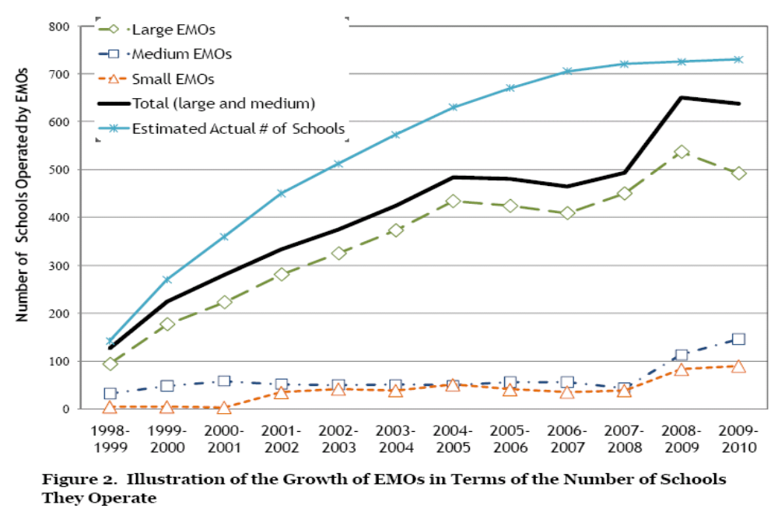

Prior studies

Hallinger et al. (1996) analyzed …..
…. situation due to its homogenous society.
Meier et al. (2007) suggested …..

Theoretical background

XX Theory; 00 Approach

Figure 2

Point of view on …. (Yoo et al., 2004)
Production orientation Employee orientation

Classification of ….

Table 1

Result of ….
a
b
c
total

HYPOTHESES

Data Sources and Method

Data Sources

Method

Measurement
Explanation for Variables (MUST in research design)
Variables | Factors |  | Explanation
Dependent
Independent
Control

(EXPECTED) Results and CONTRIBUTIONS

In xxx analysis,

Table 4

Results (not it research design)
 | Basic
 | 25.980  (25.243) | 41.279  (36.526)
 | 95.635***  (32.880) | 149.161***  (45.472)
 | 88.184***  (25.155) | 162.277***  (36.435)
343.205***
(24.507)
 | 0.333
Observations | 123
Note: *** p<0.01, ** p<0.05, * p<0.1

Conclusion

The main purpose of this study was …..

<Appendix 1>

References
Journal references
Hallinger, P., Bickman, L., & Davis, K. (1996). School context, principal leadership, and student reading achievement. The Elementary School Journal, 96(5), 527-549.
Meier, K. J., O’Toole, L. J., Jr., Boyne, G. A., & Walker, R. M. (2007). Strategic management and the performance of public organizations: Testing venerable ideas against recent theories. Journal of Public Administration Research and Theory, 17(3), 357-377.

Book references
Blake, R. R., & Mouton, J. S. (1985). The managerial grid III. Texas, TX: Gulf Publishing Company.
More than 2 authors
Yoo, B. S., Park, J. M., Park, H. B., Jang, I. S. & Cho, N. K. (2004) Principles of Management. (3rd ed.). Seoul, South Korea: Hakhyunsa.

Etc.
Molnar, A., Miron, G., & Urschel, J. (2010). Profiles of for-profit education management organizations: Twelfth Annual Report - 2009-2010. Michigan, MI: The National Education Policy Center.

For example, some schools pay incentives based on …..

